LED Flood Light
RGBW 4IN1
Client
Project
Order Code
QTY

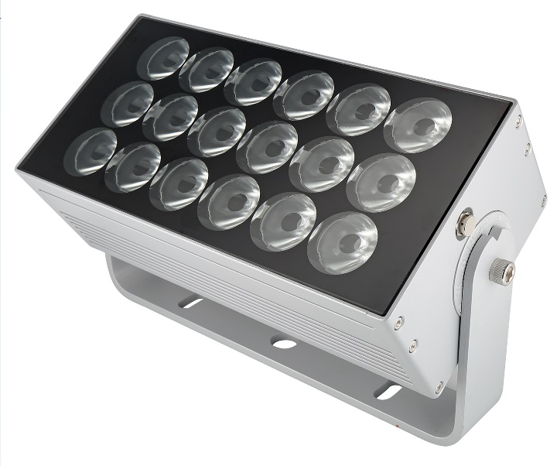
150W

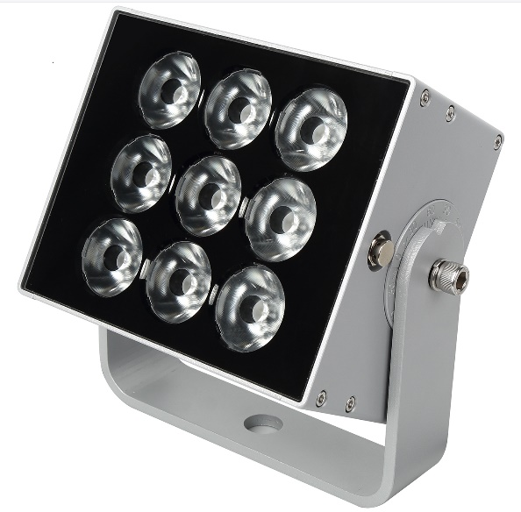
75W

Thank you for purchasing the Colordreamer LED Flood Light
Our manual will describe the installation and mounting of the product as well as a description of how to use it. Please read and understand this manual in its entirety before using the product.

Product Warranty is void if product is not installed as per installation instructions and in compliance with all local and provincial codes.

SAFETY RECOMMENDATIONS AND WARNINGS
Do not make modifications or alter the product
Keep away from flammable material.
Do not hose or pressure clean.
Do not use any silicone or other chemicals on outside surface.
Do not use chemicals or abrasives to clean the luminaires as this may voids the warranty.
Ensure installation complies with local electrical rules and regulations.
Ensure mains input power is surge protected
Do not connect or disconnect the luminaire while the power is connected.
Connectors are to be kept clean and dry at all times.
Once installed, all connectors are to be mated and a terminating plug or end cap is required on the last fitting of run.
When placing the luminaries in an end-to-end setup, be sure to leave a minimum gap of 10mm to allow the thermal expansion
Colordreamer Products are cooled by convection. Provide adequate ventilation by providing free air flow around.
If the ambient temperature around the luminaires exceeds 55degrees, do not use the products and turn off the system.
Power off the luminaires during service or when not in use.

Product Overview
This LED Flood Light is designed for architectural Facade, bridge and so on.
It can deliver high efficiency light output and uniform beam with professional lens.
We used Top Brand Silicone for better heat conduction, strong temperature withstands and perfect waterproof performance.
Apply solid capacitor and other good brand components on PCB for long life time.
Save 40% power with more efficient power management design.
With wide voltage range design, LED color always keep same brightness after long distance power supply.
Standard DMX512 control protocol (Max 44frames/second).
The communication between lights is synchronized perfectly under support of Colordreamer Artnet Controller.
Lightning and ESD Protection
Electrical Protections: short circuit, over current, over voltage and over temperature.

Product Specification
Models | F1850904 | F1851804
LED
Color | RGBW 4IN1 | RGBW 4IN1
Light Source | High Power LED | High Power LED
LED Source Color | R:620-625nm  G:524-529nm  B:452-457nm  W:6000K | R:620-625nm  G:524-529nm  B:452-457nm  W:6000K
CRI for White LED
LED QTY | 9LEDs | 18LEDs
Performance
Lumen Output | 3600lumen | 7200lumen
Efficacy | 48lumen per watt | 48lumen per watt
Beam Angle | 10°Narrow  20°Narrow Medium  30°Medium  45°Wide | 10°Narrow  20°Narrow Medium  30°Medium  45°Wide
Electrical
Input Voltage | 120-277VAC | 120-277VAC
Power Consumption | 75W | 150W
Control
Protocols | DMX/RDM | DMX/RDM
Addressing | Manual Addressing with Colordreamer Addressing Tool
Pixels | 1Pixel | 1Pixels
Physical
Housing | Aluminum 6063 with Tempered Glass
Finish Color | Powder coating, Black/Grey Silver or Custom RAL Color
Dimensions(LXWxH) | 220X185X118.5mm (exclude brackets) | 385X185X118.5mm (exclude brackets)
Dimensions(LXWxH) | 220X185X225mm (include brackets) | 385X185X225mm (include brackets)
Cable Entry | Bottom Entry
Mounting | Surface Mounting
Accessory | Half Glare Shield
Packing | Update soon
Environment
Operating Temperature | -30℃ to +50℃
Storage Temperature | -40℃ to +70℃
Humidity | 0-90% non-condensing
IP Rating | Dry, Damp, Wet locations IP66
Certification and Safety
Certification | CE
Wrranty | 2Years Limited Warranty from the Date of Manufacture  Contact us if you need extended warranty
Remark: The given data of CCT, beam angles, lumen output and electrical power are typical value. Due to the tolerances of the production process and the electrical components, the values can vary up to 10%.

Dimension
75W Version
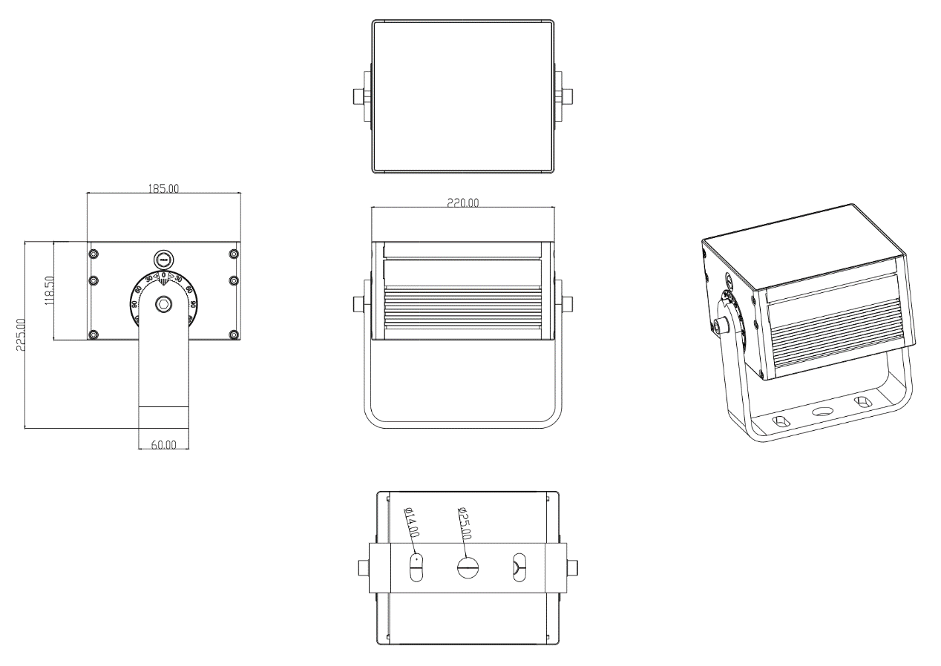
150W Version
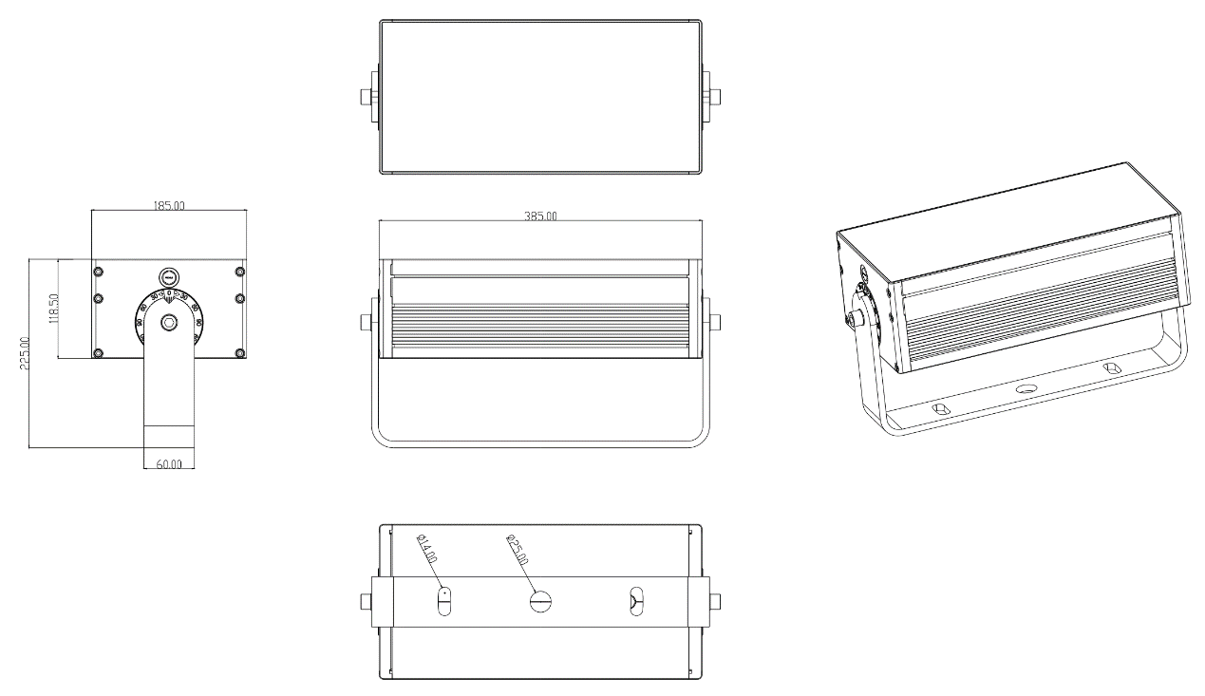
Photometrics
Update Later

System Diagram

Wire Color and Designations for AC Input
Wire | Color
Brown | AC L
Blue | AC N
Yellow/Green | AC GND

Wire Color and Designations for DMX IN and Out
Wire Color | Description
Red | N/C
Black | Power and Signal GND
Green | DMX+
Blue | DMX-

Accessories List (Need Order Separately)
Name | Order Code | Description
Leader Cable | 67E4FB-20CM | IP67 Connector,20cm Long 4PIN Female to open wire
Leader Cable | 67E4FB-5M | IP67 Connector,5Meter Long 4PIN Female to open wire
Jumper Cable | 67E4M4F-5M | IP67 Connector,5Meter Long 4PIN Male to 4PIN Female
IP67 Connector to XLR Cable | 67E4F5XM-20CM | 20CM Long 4PIN IP67 Female Connector to XLR 5PIN Male Cable
IP67 Connector to XLR Cable | 67E4F5XM-5M | 5M Long 4PIN IP67 Female Connector to XLR 5PIN Male Cable
DMX Terminator | CD-DT4M | 4PIN Male DMX Terminator with 120Ω Resistor Between DMX+ and DMX-
End Cap | CD-EC | End cap for female connector

